ADULTS  Grief doesn’t discriminate. It affects all people of all ages, often adults feeling the worst of it. They knew the person. They understand that they won’t see them again. There’s no sugarcoating their loss. Listed below are five of the best books to help adults deal with bereavement:  - ‘Tiny Beautiful Things’ by Cheryl Strayed. A book of wisdom and honesty in sectioned advice columns from Cheryl’s old days of being the neighborhood agony aunt.  - ‘H is for Hawk’ by Helen Macdonald. After the sudden loss of her dad, Helen adopts a hawk and remind her readers of the beauty of nature when dealing with grief.  - ‘Grief is the Thing with Feathers’ by Max Porter. After a man losing his wife suddenly and being left with his two young sons, grief and fear takes over his life. It’s through the help of a crow that help them cope with the loss.  - ‘Bearing the Unbearable’ by Joanne Cacciatore. Jo navigates her way through loss and expertly reveals how the death of a loved one can open sides into people, perhaps never seen before.  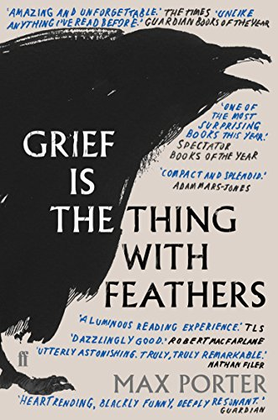  - ‘The Art of Losing’ by Kevin Young. A carefully selected collection of poems about Young’s five sections of grief: reckoning, remembrance, rituals. recovery and redemption.
  For further information on dealing with loss and bereavement, visit the following links:
  https://www.nhs.uk/mental-health/feelings-symptoms-behaviours/feelings-and-symptoms/grief-bereavement-loss/
  https://www.cruse.org.uk/
  https://www.helpguide.org/articles/grief/coping-with-grief-and-loss.htm#
  https://kidshealth.org/en/teens/coping-grief.html
  https://www.youtube.com/watch?v=Jl7axuIeVxI
  https://www.youtube.com/watch?v=gsYL4PC0hyk
  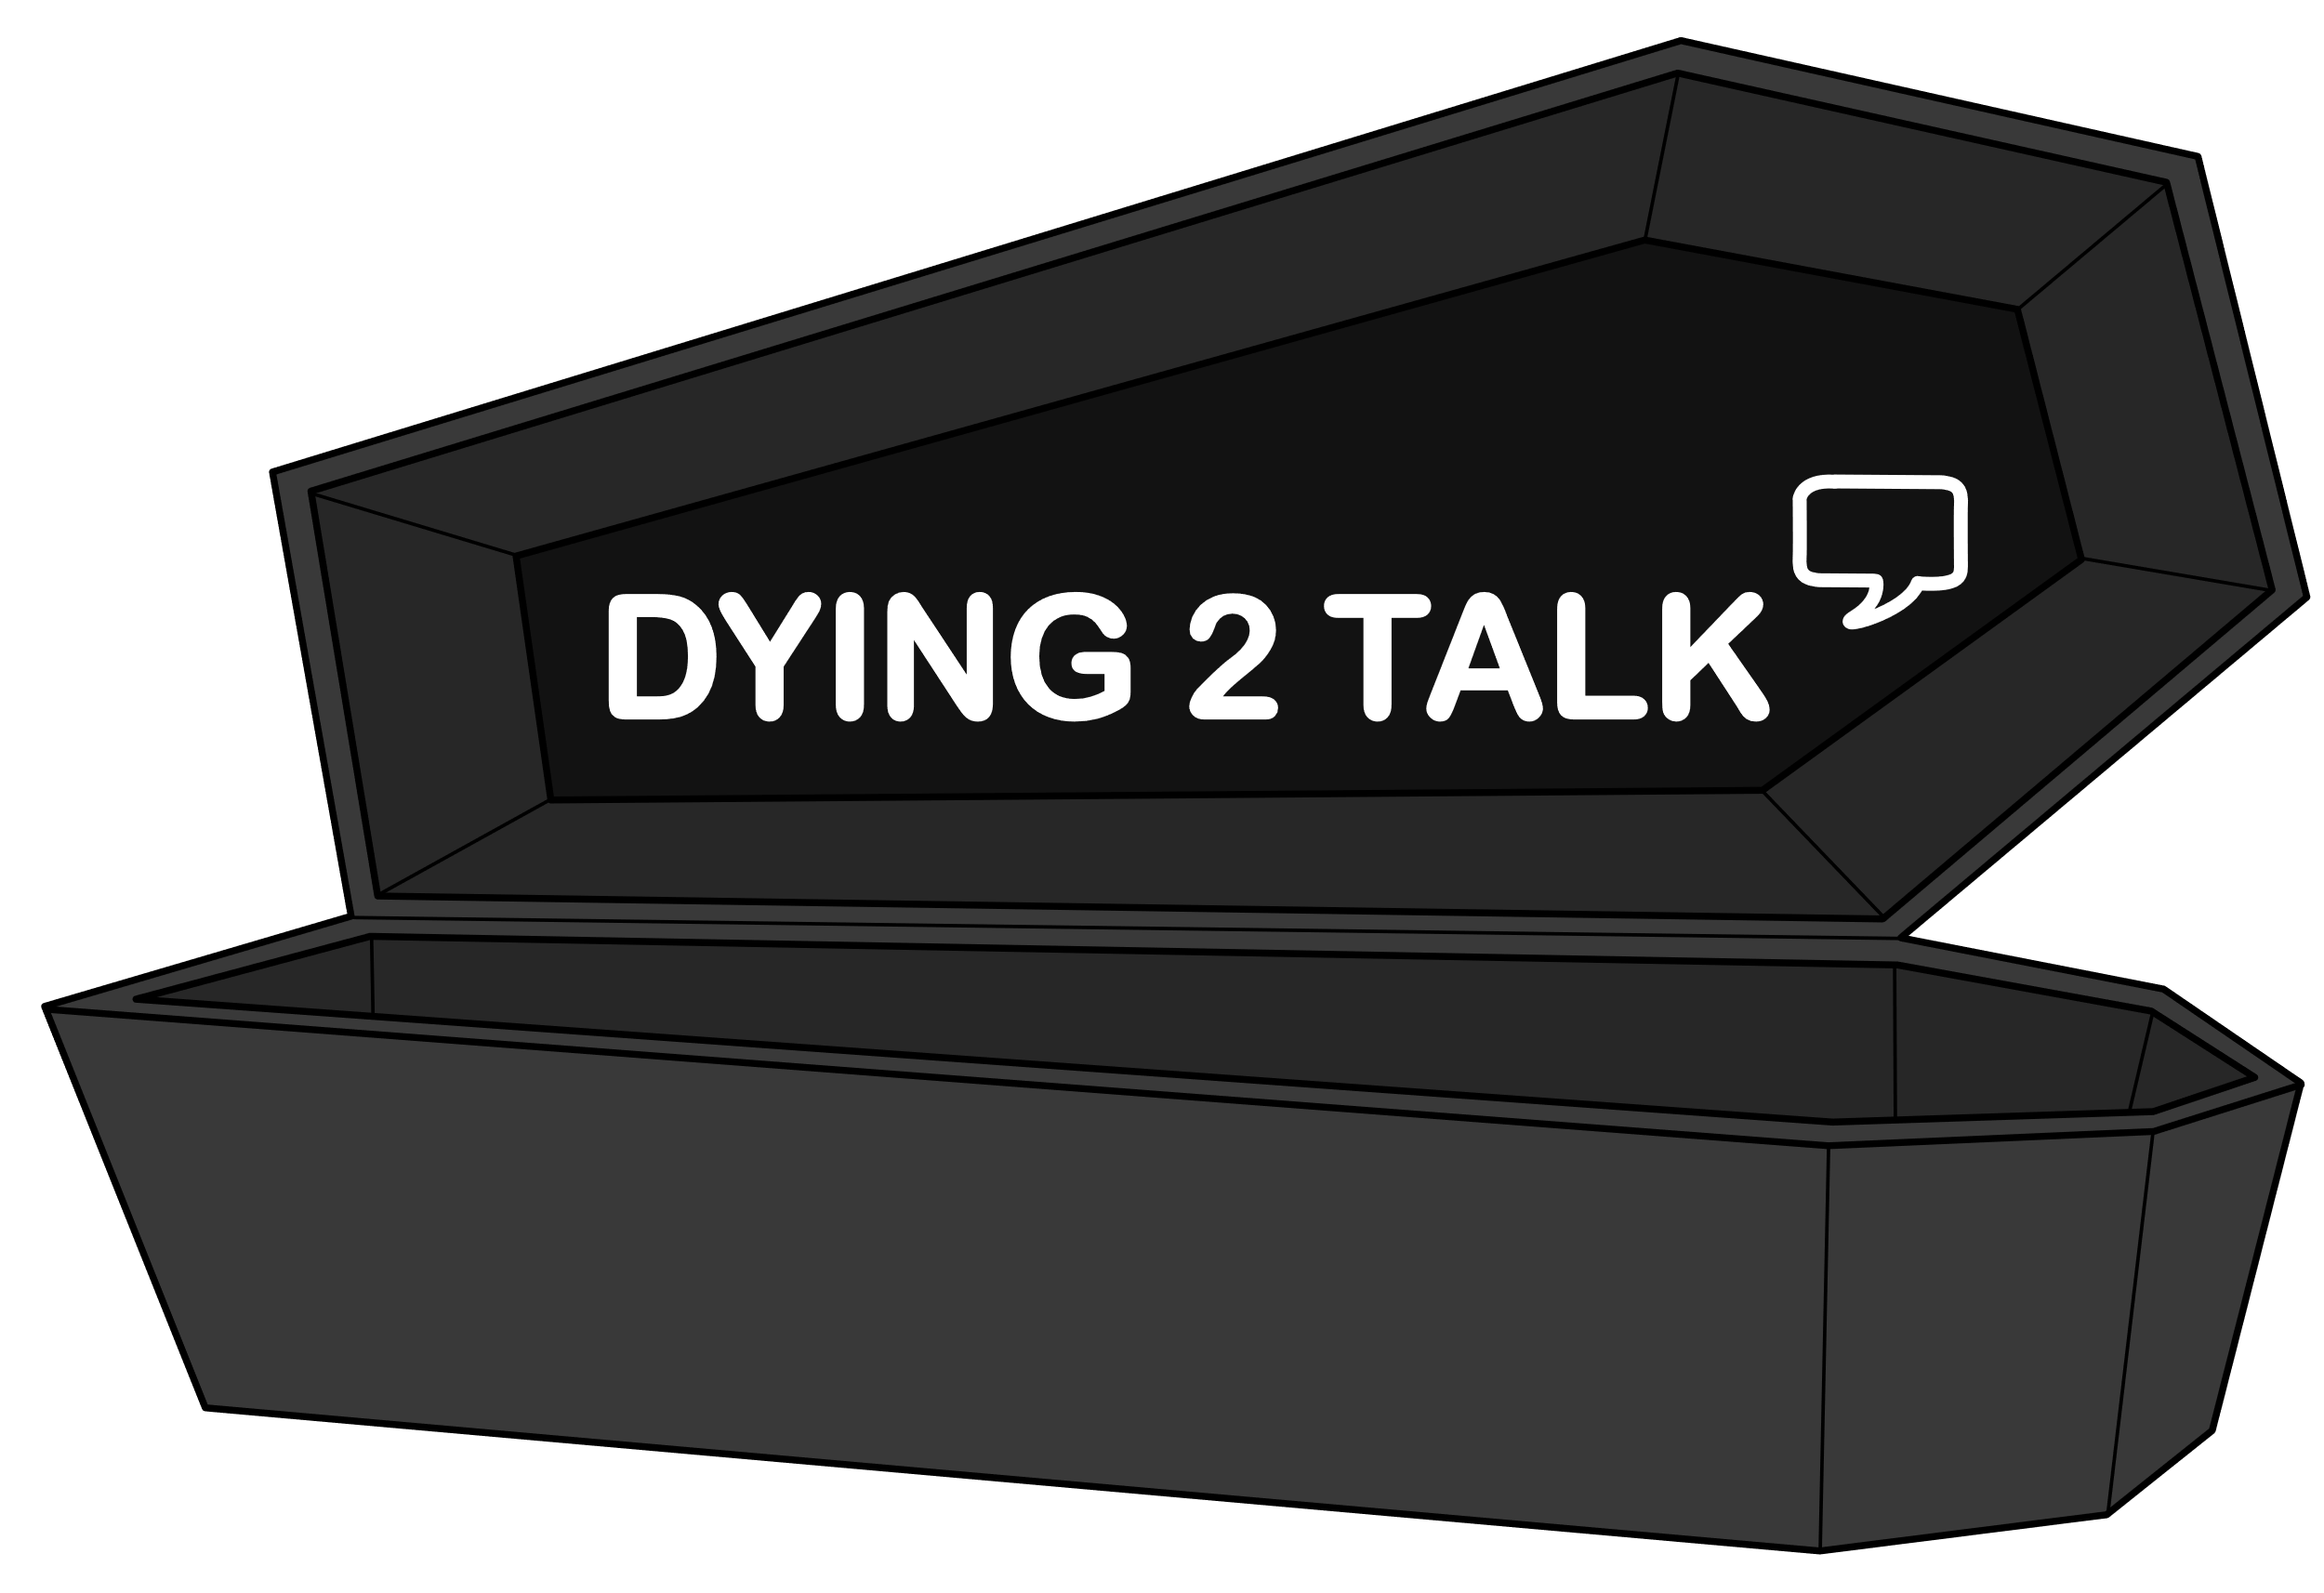 | Dying to Talk’s 15 BEST BOOKS FOR DEALING WITH LOSS
  0808 808 1677 – Cruse Bereavement Care
  0800 028 8440 – Child Bereavement UK
  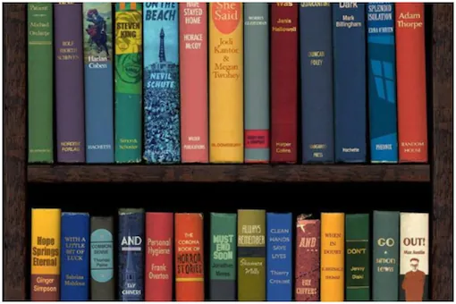
  Dying to Talk’s 15 BEST BOOKS FOR DEALING WITH LOSS
    - For children, young adults, and adults
From as early as when they were toddling around the house to deep into their twenties and further, millions of people around the world face loss. It’s been happening for about as long as we can remember. You know what else is really old? Books.  Since as early as BC, books have been a staple item, generations pouring out their experiences, their imaginations, their knowledge all into small papers just for us. Pretty cool, right? In this small handy leaflet, we’ve list 30 of our favorite bereavement books, divided into categories for children, YA, and adults. They’re something for everyone! And without further ado, Dying to Talk presents their 15 best books for dealing with a loss! First up, children. | CHILDREN  Often, children feel confused or worried, some even feeling angry. How come Grandad gets to go to a ‘better place’ and leaves me here? We’ve compiled a list of five helpful books to help children deal with the loss of a loved one:  - ‘The Invisible String’ by Patrice Karst. Twins Jeremy and Liza talk with their mum about the invisible string that we are all connected to, no matter where you are.  - ‘Where are you Lydie?’ by Emma Poore. Focusing on the loss of a sibling, young George and Henry are left feeling confused when their baby sister is no longer there and talks with mum and dad.  - ‘The Goodbye Book’ by Todd Parr. Written through the perspective of a fish losing a friend, the book travels on a journey to teach children that it’s normal to feel sad but it will be okay.  - ‘Vicky’s Angel’ by Jacqueline Wilson. After hearing her best friend Vicky was killed in a car accident, Jade was in ruins, until she begins to see her ghost.  - ‘Tear Soup’ by Chuck DeKlyen and Pat Schwiebert. An elderly woman by the name Grandy process her grief through making big batches of her special ‘tear soup’.  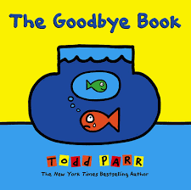  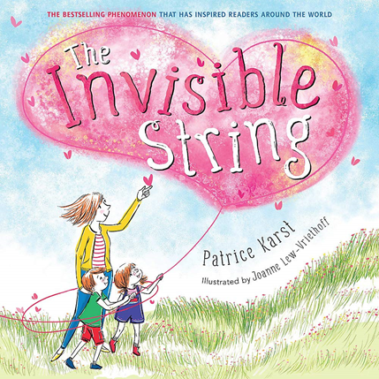 | YOUNG ADULTS (YA)  .  Ranging from 13 to 19 years old, teen grief is one of the most impactful times. Their grief is perhaps one of the most complex as they have more of an understanding of death than their younger siblings but typically not exposed to it as much as their parents and therefore, split in the middle. Below this is a carefully curated list of the five best books to help teenagers deal with grief:  - ‘The Fault in Our Stars’ by John Green. Whilst struggling with a terminal illness her whole life, Hazel Grace Lancaster meets Augustus (‘Gus’) Waters, a teenage cancer patient, desperate to be remembered by the world  - ‘They Both Die at the End’ by Adam Silvera. Fitting for teenagers struggling with a nothing matters in life point of view, it follows the story of two boys, Rufus, and Mateo, spending their last day alive.  - ‘All The Bright Places’ by Jennifer Niven. Whilst battling with the loss of her younger sister, teenager Violet meets Theodore, a boy intending to die. A heart tugging romance for all.  -We Are Okay’ by Nina LaCour. College student Marin rushes to escape her life after the sudden loss of her grandfather. It’s not until her best friend Mabel arrives that she sees her wrong  - ‘A Man Called Ove’ by Fredrik Backman. After the death of his wife, 60-year-old Ove in Sweden is left contemplating the rest of his life without her. It’s not until a family moves next door that he sees life may be okay still after forming an unusual friendship.

